**Project Overview**

* **Platforms**: Android, iOS, Web
* **Tech Stack**:
  + **Frontend (Web View / Hybrid App)**: HTML, CSS, JavaScript
  + **Backend API**: ASP.NET Core Web API
  + **Mobile App**: **MAUI** (recommended for .NET 8.0)
  + **Database**: SQLite (local storage when offline) + SQL Server (backend)
  + **Authentication**: Secure PIN-based login
  + **Data Sync**: REST API with offline sync support
  + **Security**: HTTPS, AES encryption for local DB, JWT tokens for API

**System Architecture**

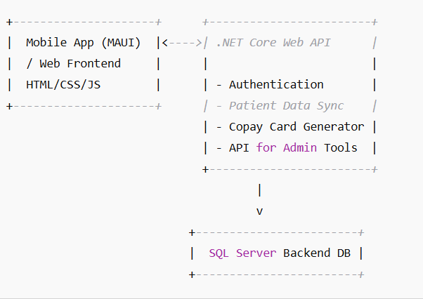

## Functional Modules

### 1. **User Registration & Login**

* Registration with PIN
* Form captures:
  + Name, DOB, Email, Phone
  + HCP specialty
  + Treatment Indication
  + Insurance Type
  + Email/Text Consent
* PIN-based authentication with fallback to OTP/email for recovery

### 2. **Data Management**

* Local database (SQLite for mobile)
* Automatic sync to backend (SQL Server) on network availability
* Conflict resolution policies

### 3. **Copay Card Generator**

* Business logic: Based on Insurance Type, generate copay card
* Copay card details:
  + Card number
  + Discount amount
  + Validity
  + QR Code/barcode
* Stored in patient’s profile (available offline)

### 4. **Offline Mode**

* Store data in SQLite
* Sync queued data to backend when online
* Use HTTP status for retry mechanisms

**Security Requirements**

* **Encryption**:
  + Data at rest: AES-256 (SQLite encryption)
  + Data in transit: HTTPS (TLS 1.2+)
* **Authentication**:
  + JWT tokens
  + Expiry/refresh logic
* **Compliance**:
  + HIPAA-compliant storage
  + Consent checkbox for communication

**Mobile & Web Frontend UX Design**

* Accessibility-first design (arthritis-friendly):
  + Large touch targets
  + Voice input support
  + Contrast and readability
* Web: Responsive design for tablets and desktops
* Mobile: MAUI app with adaptive layouts

## Technical Stack Details

| **Layer** | **Technology** |
| --- | --- |
| Mobile App | .NET MAUI (iOS + Android) |
| Web Frontend | HTML5, CSS3, JS |
| Backend API | ASP.NET Core Web API |
| Sync & Auth | REST API, JWT |
| Local Storage | SQLite + Sync Engine |
| Backend DB | SQL Server |
| Hosting | Azure |

**Deployment Plan**

* **Mobile**:
  + Build & deploy MAUI app for Android and iOS
  + Prepare .apk and .ipa packages
  + App Store submission with review notes
* **Web**:
  + Host HTML frontend using .NET Core MVC or Blazor
  + Deploy API to Azure App Service or Docker-based container
* **Documentation**:
  + Setup guide
  + Configuration guide
  + Deployment instructions
  + API Swagger documentation